One thing to keep in mind is that we have to falsify our identity, including nationality, age, experience, and name. In some cases, a fake gender is also required.

***The first thing we need to do is to install AdBlock, smart proxy and xblocker according to RB's policy.***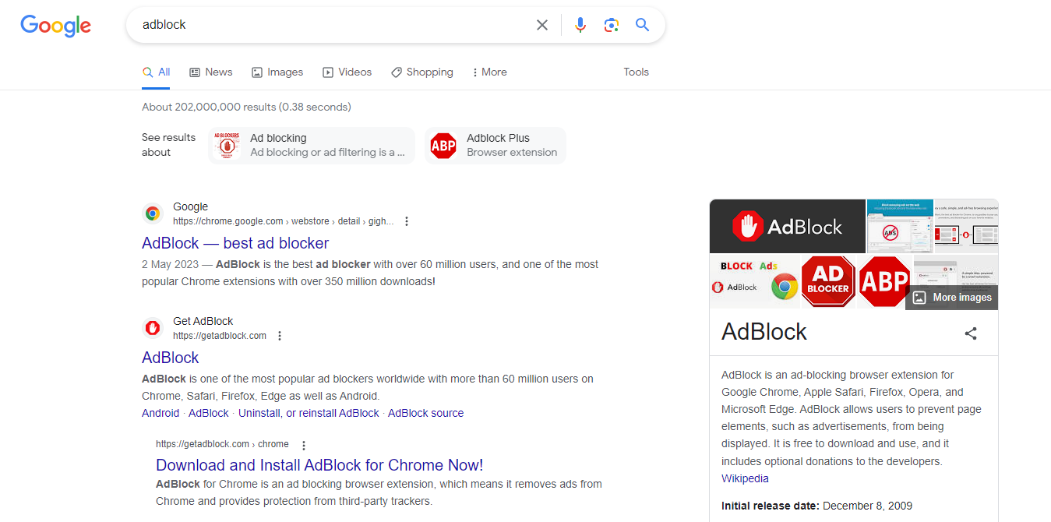

On the Internet, at any time (that is, at unexpected times and at very rapid intervals), numerous advertisements from all walks of life are displayed as notifications on your computer. Viewing ads is prohibited.

We don't have to do anything that isn't related to development.

AdBlock is an extension that prevents ads from appearing. But don't think of it as complete. Even though you have AdBlock installed, you may see nasty ads at any time (which is unlikely, of course). In this case, we must terminate, write and report according to the Internet browsing policy. For instance, if we see something bad on the internet (unconsciously, of course), don't panic.

Close immediately and write details on the book e.g. while browsing https://dictionary.cambridge.org on 5/5/2023 at 4:00 PM, I noticed an incorrect picture displayed, so I have closed and reported to the manager), get the manager's signature. all right?

***The first thing to do is create a Gmail account.***

However, there is no problem in creating an account because XXX does it.

Gmail (pronounced Gee-mail) is a free web-based email service that provides users with 15 GB of message storage and the ability to search for specific messages.

The Gmail program also automatically organizes consecutively related messages into conversation threads.

Gmail (also known as Google Mail) can be accessed from a personal computer, tablet, or any Android or iOS device.

According to Google co-founder and CEO Larry Page, the company was inspired to create Gmail by letters from users complaining about problems with existing email services such as Yahoo Mail and Microsoft Outlook.live.com (formerly Hotmail).

Their complaints included the lack of searchability and the need to constantly delete messages to stay within storage limits.

There are many services on the Internet that require a Gmail account, so for these services all you need is a Gmail account without a newly created one.

Great. Let's say you have a Gmail account and your name is nataliehall179@gmail.com. (For one thing, "Natalie Hall" is a Canadian female name. Unfortunately, I got the account based on a female name.)

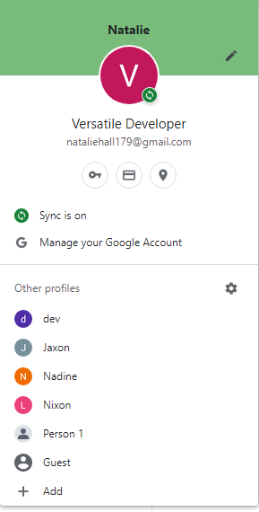

***The first step I recommend is to create a GitHub account.***

The reason this is the first step is that GitHub shows the developer's history, skills, level, etc. In other words, your GitHub profile is an implied bulletin board that showcases your development abilities.

However, if you create a new account and repository, the commit history will only be there for a few days, and may not exist at all.

You have to fake your senior developer status with 5-7 years of development experience. But what if a customer who wants to give you some work asks to see your GitHub profile? Do you have any plans?

Probably not.

Well, now I'm going to give you some tricks.

The link below is a node module that fakes the commit history.

https://github.com/artiebits/fake-git-history

fake-git-history is a tool created by Artie Bits that creates fake commit history for Git repositories. This tool allows you to create a realistic commit history for your Git repositories, complete with various commit messages, author names, and timestamps.

This tool can be useful for a variety of purposes: creating sample commit records for new repositories, creating demos or presentations of Git features, or simply for fun.

The fake-git-history tool is open source and available on GitHub. You can download the source code here and run it on your local machine. This tool is written in Python and uses the gitpython library to interact with Git repositories.

It's important to note that fake-git-history can create fake commit history, but it doesn't actually create code or files for your repository. Generate only commit history with bogus message, author, and timestamp.

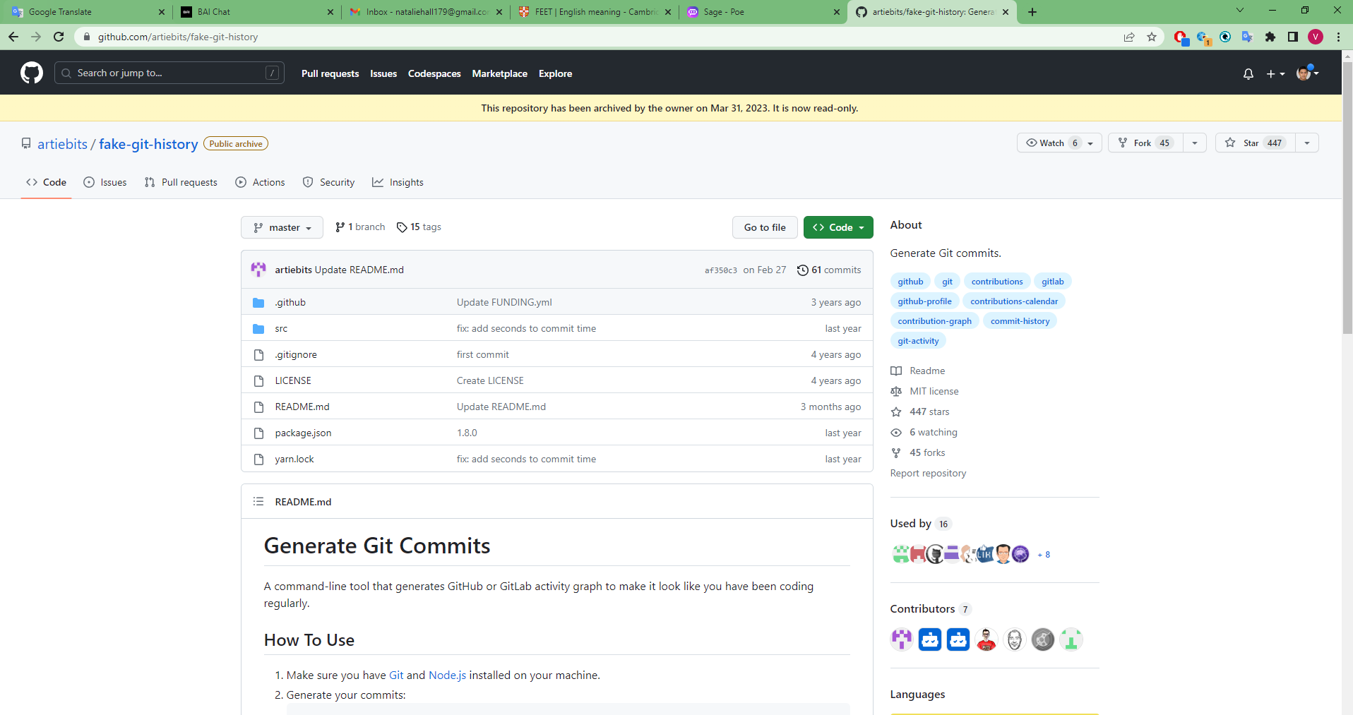

Perhaps such methods have been introduced in detail.

So it totally depends on your cognitive abilities.

Then the commit history is enough, but the repo is not there yet.

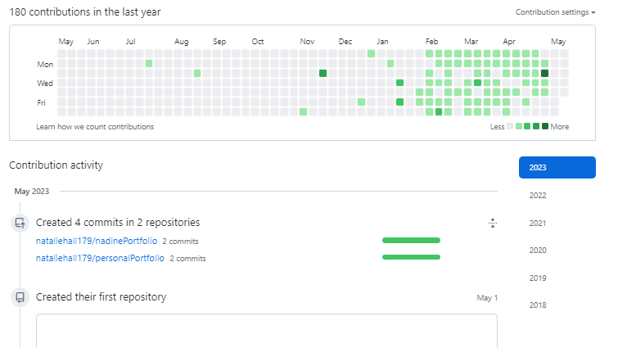

If you are a web developer, your GitHub repository should be full of many web projects including MERN projects, MEAN projects, Laravel, and more.

In this case, don't create the project from scratch. Here are some good tips.

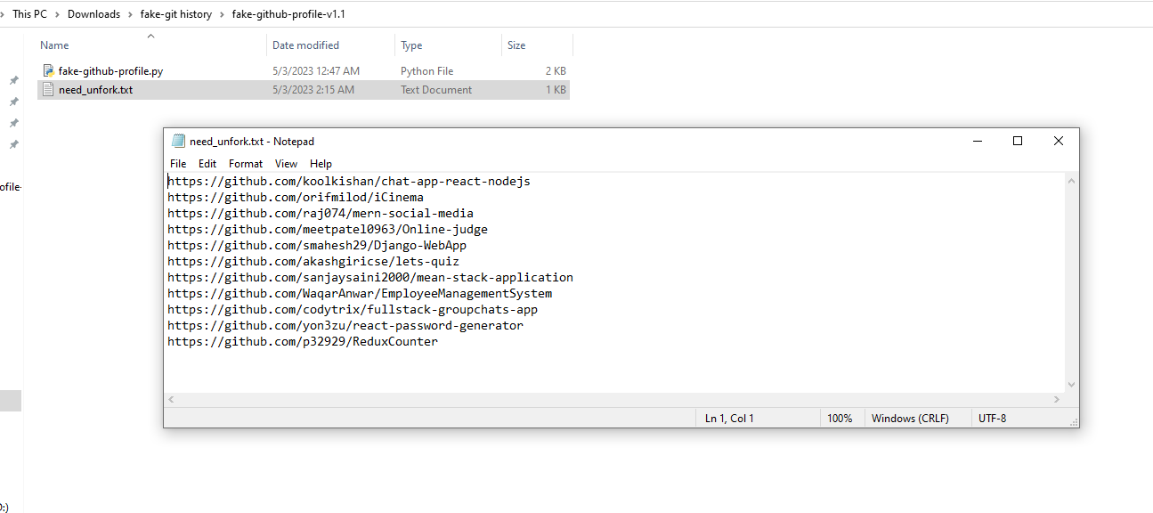

The Python code mentioned above clones a similar, suitable project and automatically creates a repository with that project. Just search for similar projects on GitHub and put the URL of that project into a .txt file.

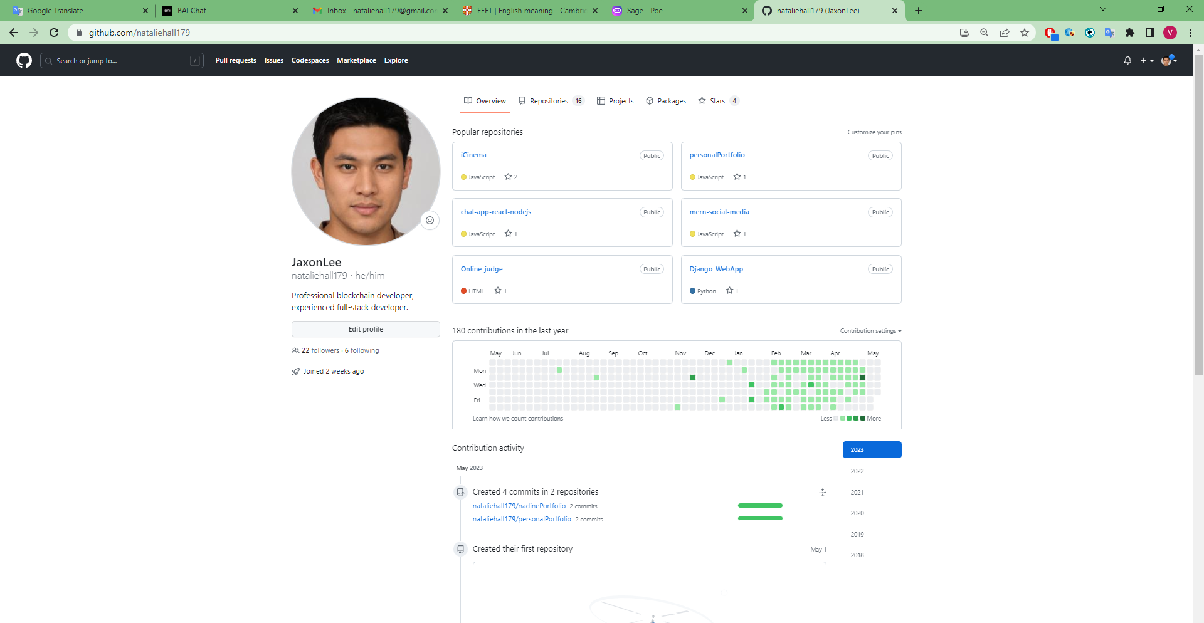

We are almost ready.

***A final requisite to posing as a real senior developer is a resume and portfolio.***

A resume is a document that summarizes a person's education, work experience, skills, achievements, and other pertinent information for the purpose of demonstrating qualification for a job or other opportunity.

Typically, a resume is a one-to-two-page document that provides a concise overview of a person's professional background and achievements. A well-written resume should highlight the candidate's strengths and relevant experience while being legible and visually appealing.

A resume is often required as part of the job application process and is usually submitted along with a cover letter. Employers use it to screen potential candidates and determine whether they meet the requirements for a particular job.

Resumes can take many formats and styles, but typically include the candidate's contact information, summary of professional experience, education, skills, and achievements. It's important to tailor your resume to the specific job or opportunity you're applying for and highlight your most relevant qualifications and experiences.

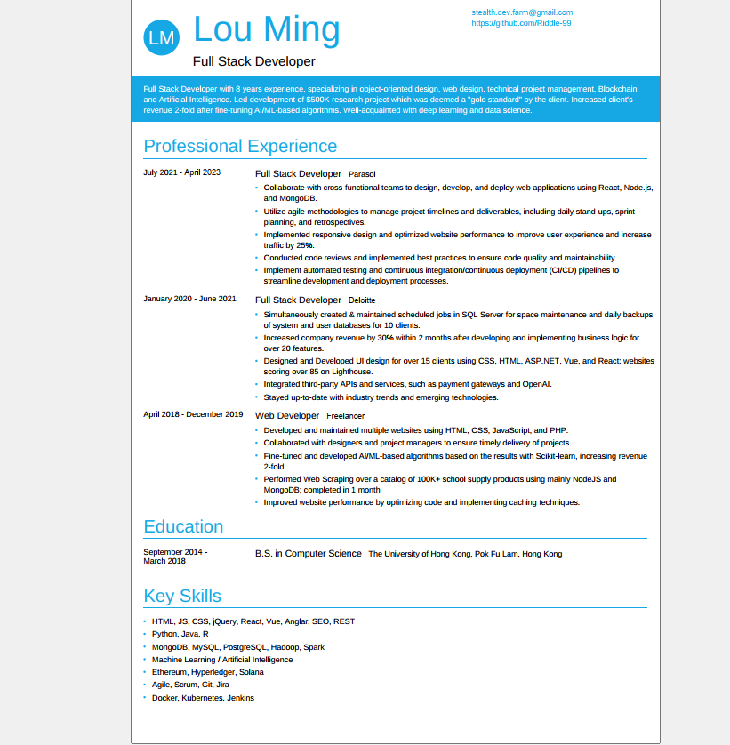

A portfolio is a collection of work samples, projects, and other materials that demonstrate an individual's skills, abilities, and achievements in a particular field or area of expertise. Portfolios can take many forms, including physical or digital collections of documents, images, videos, and other media.

Portfolios are often used by professionals in creative fields such as graphic design, writing, and photography, but can be useful in many other industries as well. A well-structured portfolio can help showcase your individual talents and achievements, differentiate you from other candidates, and provide evidence of your skills and abilities to potential employers or clients.

Portfolios can be useful in a variety of situations, such as:

Job Application: Including a portfolio on a job application can help demonstrate a candidate's qualifications and experience and provide evidence of their skills and abilities.

Networking: Sharing your portfolio with potential clients or collaborators can help you showcase your individual work and abilities and build trust.

Self-promotion: Using a portfolio as part of a personal branding strategy can help establish the person as an authority in the field and attract new clients or opportunities.

Overall, portfolios are valuable tools for professionals in a variety of fields. This is because it showcases your work and achievements and sets you apart from other candidates and competitors.

